Tray clearing trolley, TAW 2x10 EN

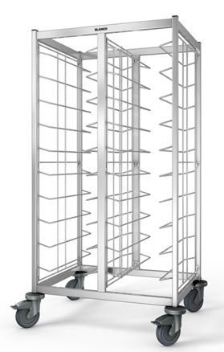

Dimensions

Length: 940 mm
Width: 673 mm
Height: 1550 mm
Height incl. trolley top (optional): 1586 mm

Model

The tray clearing trolley has two pieces and is made completely of stainless steel, AISI 304. The frame construction is made of sturdy square tube (25x25 mm and 40x20 mm) and is welded all round.
The tray supports are made of round material with a dia. of 6 mm, and can be mounted and securely fastened within the frame construction. This means that the support frames can be completely removed if necessary. Through the bars that are welded at an angle, the tray supports are equipped with integrated push-through protection on both sides.
The tray clearing trolley can be loaded from both sides and has a capacity of 2x10 EN trays (530x370 mm). The support spacing is 125 mm.
The trolley is mobile on corrosion-resistant synthetic castors pursuant to DIN 18867, Part 8 (4 steering castors, 2 of which have brakes, castor diameter 125 mm). Synthetic (polyamide) round wall guards at all four corners protect against damage.

Accessories/options

- Thin sheet panelling on 2 sides, electrolytically galvanised double-sided, powder-coated in various colours, for mounting on the tray clearing trolley. Can be easily removed without any tools for cleaning.
- Stainless-steel panelling on 2 sides, for mounting on the tray clearing trolley. Can be easily removed without any tools for cleaning.
- Thin sheet panelling on 3 sides, electrolytically galvanised double-sided, powder-coated in various colours, for mounting on the tray clearing trolley. Can be easily removed without any tools for cleaning.
- Stainless-steel panelling on 3 sides, for mounting on the tray clearing trolley. Can be easily removed without any tools for cleaning.
- Doors made of thin sheet, two-walled for more stability, electrolytically galvanised double-sided, powder-coated in various colours. Optionally available closed or with glass insert made of tempered safety glass.
- Doors made of stainless steel. Optionally available closed or with glass insert made of tempered safety glass.
- Stainless-steel trolley top with all-round railing. For mounting on the tray clearing trolley. Can be easily removed without any tools for cleaning. The maximum permissible surface load is 20 kg.
- Base made of stainless steel for inserting in the frame construction. Can be easily removed without any tools for cleaning.
- Additional stainless-steel push-through protection
- Push handle short side
- Galvanised steel castor set

Technical data

Material: Stainless steel,
synthetic (polyamide)
Weight: approx. 33 kg
Max. load-bearing capacity
trolley: 150 kg
Max. load-bearing capacity/
support pair: 4.5 kg
Number of support pairs: 20
Capacity: 20 Euronorm trays,
530x370 mm
Support spacing: 125 mm

Tray insertion: Lengthwise

Special features

- Tray supports with integrated push-through protection on both sides
- Tray support frames are completely removable
- Optional panelling (on 2 or 3 sides) for mounting on the TAW. Can therefore be easily removed for cleaning.
- Attachments like panelling, doors, top and base can be retrofitted at any time.

Make

Manufacturer: B.PRO
Model: TAW 2x10 EN
Order No. 574 244

