# SERVISTAR GASTRO 80

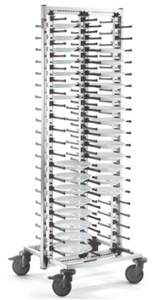

**Dimensions**

Length: 653 mm

Width: 663 mm

Height: 1856 mm

**Model**

**Design**

The SERVISTAR GASTRO 80 consists of a transport frame, a support frame and four integrated ladders with plate holders. The transport frame and support frame are each welded and extremely resistant to bending and twisting. The two frames share a sturdy connection with two large screws. The plate holders which hold the inserted plates securely in place are mounted on profile tubing. The profile tubing is mounted to the support frame using adjusting screws and can be steplessly adjusted to all plate sizes up to 30 cm. Reference markings on the upper side and underside of the support frame make adjustments easier. The plates rest on the plate holders in a soft and non-slip position due to the unique shape and soft-grip surface. The plate holders are individually mounted to the profile tubing and can thus be replaced quickly and easily if service is required.

**Use/ ergonomics**

The plate stacking system B.PRO SERVISTAR is designed for the space-saving serving and secure transport of portioned plates in restaurants, hotels, and social facilities.

The SERVISTAR GASTRO 80 is mobile on corrosion-resistant synthetic castors pursuant to DIN 18867, Part 8 (4 steering castors, 2 of which have brakes, castor diameter 125 mm). The castors are screwed to the transport frame. Sturdy synthetic wall guards at all four corners protect the trolley against damage.

**Accessories/options**

* Height-adjustable push handle, Art. 573717
* Hygiene shrouding incl. AISI 304 frame construction, Art. 573715
* Table platform
* Plate block
* Galvanised steel castors
* Stainless-steel castors
* Delivered in the space-saving Flat Pack for self-assembly

**Technical data**

Material: AISI 304, anodised aluminium, PE,   
PA 6 TPE

Weight: approx. 23 kg

Capacity: 80 plates

Number of plate rows: 4 for 20 plates each

Max. load-bearing  
capacity: Per pair of plate holders: 1 kg

Plate spacing: 80 mm

Plate sizes: Steplessly adjustable up to   
 30 cm

### Special features

* Uniquely formed plate holders with soft-grip surface
* Large plate spacing of 80 mm

**Make**

Manufacturer: B.PRO

Model: SERVISTAR GASTRO 80

Order No. 573695