# B.PROTHERM 620 KBRUH-F

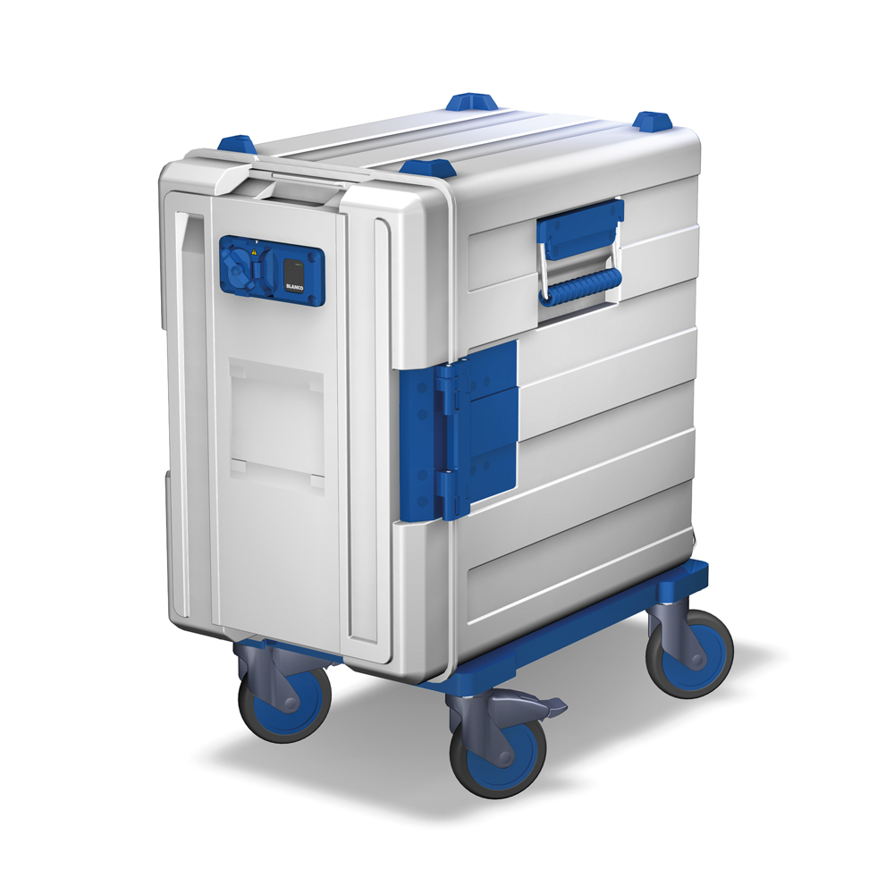

**Dimensions**

Length: 742 mm

Width: 440 mm

Height: 831 mm

**Model**

The food transport container is manufactured with the thermoforming process and consists of high-quality, non-hazardous, food-resistant polypropylene.

The double-walled synthetic container and the door are filled with PUR foam for thermal insulation. Inside and outside containers are welded to be leak-free. The synthetic surface is smooth and non-porous.

Stainless-steel carrying handles with ergonomically shaped synthetic carrying handles are located on the long sides of the body recessed in depressions. The stainless-steel carrying handles enable wear-resistant use, even with heavy loading.

The container is equipped with a hinged door that can be swivelled by 270° and removed if necessary. The patented door hinge ensures that the door can only be removed in a predefined position. This prevents accidental removal of the door and the related danger of injury.

The door is locked with a stainless-steel bent-clamp closure on the long side of the container, which engages in the door.

A device for holding marking cards is integrated on the door to identify the food in the container.

The top of the container is provided with four screwed-on stacking corners. All B.PROTHERM containers can be stacked with one another.

The container is equipped with a transport frame, consisting of a bottom plate made of polyethylene. Four synthetic steering castors with a diameter of 125 mm, corrosion-resistant pursuant to DIN 18867-8, two of which have brakes, are attached to the sturdy bottom plate.

All wearing parts (stacking corners, handles, door hinges and door lock) can easily be replaced if service is required. All countersunk screws are covered with synthetic plugs for hygienic reasons.

The BPT 620 KBRUH is loaded from the front. The inner body of the container is equipped with 12 pairs of moulded support ledges with a spacing of 39 mm for holding Gastronorm containers.

The convection heating module is permanently integrated inside the hinged door. The electrical connection with a power plug coupling, which can be locked protected against splashed water with a special rotary lock, is located in the upper area of the door.

The digital control with an LED display is located next to this.

The temperature inside the container can be adjusted down to the degree from +40 °C to +85 °C for keeping food hot in an especially gentle and appetising way.

A temperature of approx. +90 °C is reached in Full-Power mode. The actual temperature inside the container is indicated on the LED display.

The heater is equipped with an integrated overheating protection to prevent the food from being cooked further.

The power cable supplied loose with the container.

### Accessories/options

* See full price list for various transport trolleys and castors
* Eutectic plate -3 °C (Order No. 568136)
* Eutectic plate -12 °C (Order No. 573332)
* Slide-in frame for subdivision of GN containers with a maximum depth of 150 mm

(Order No. 564 352)

* GN support bars for variable insertion of GN containers of the size GN 1/4, GN 1/6, GN 1/9 in the slide-in frame (ST 3 Order No. 550 650,

ST 5 Order No. 550 651)

* See full price list for menu cards incl. accessories

**Technical data**

Material: Polypropylene (PP),

Polyethylene (PE),

polyamide (PA),

stainless steel

Temperature

resistance: -25 °C to +100 °C

Insulating material: PUR foam, CFC-free

Ledges: 12 pairs of support ledges, spacing of 39 mm

Capacity: 2 x GN 1/1-200

Heat-up time: A temperature of approx. 75 °C is reached in 45 min. in the Full-Power mode in an empty container

Weight 27,59 kg

Connected load: 220-240 V AC/ 50 Hz/

200 W

Emissions: The workplace-specific

noise level of the unit is

less than 70 dB(A)

**Special features**

* IPX 4 protection against splashed water
* VDE-GS tested
* recyclable
* Mobile food transport container
* Temperature control down to the degree from +40 °C

to +85 °C

* Temperature display
* Heater with integrated overheating protection
* Patented door hinge (can only be removed in predefined position)
* Handle at upper left in door for easy movement and optimal handling of the container

**Make**

Manufacturer: B.PRO

Model: BPT 620 KBRUH-F

B.PROTHERM

Order No. 573 315