# STW 2 – food transport trolley

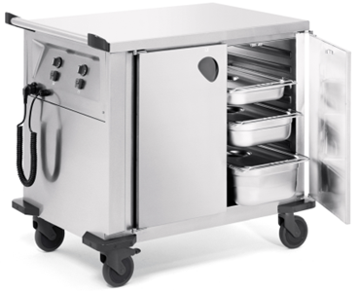

**Dimensions**

Length: 1009 mm

Width: 714 mm

Height: 915 / 885 mm

**Description**

**Structure**

The food transport trolley is made entirely of CNS 18/10 (AISI 304) with a specially ground matte surface finish (“microlised” surface).

A recessed control panel at the short side of the trolley features an on-off switch, a control indicator, a helix cord, a dummy plug socket, and a temperature control. The temperature control allows for continuous temperature setting of the heat retaining compartments.

A CNS safety push-pull handle with side bumper elements of plastic (polyamide) is mounted at the operator side. It also serves as a protection for the control elements.

The trolley is made mobile by corrosion-resistant synthetic castors (2 fixed and 2 steering castors with brakes, 125 mm ø). Very robust synthetic corner guards (polyamide) at all four corners protect the trolley from being damaged.

### Trolley body

The body of the trolley is double-walled and insulated.

The substructure features:

* Two heated compartments without joints, each with 9 pairs of deep-drawn support ledges, spaced at intervals of 57.5 mm, for GN containers size GN 1/1 or their subdivisions. The compartments can be heated and controlled separately. The compartment height is 588 mm. The hinged doors are double-walled and insulated and can be opened to an angle of 270°. The compartment doors are self-locking and are equipped with curved handles.

### Accessories / options

* all-round synthetic bumper rail (polyethylene)
* top railing either as wrap-around railing or on 3 sides
* electronic temperature control with digital display
* for other castor variations, please refer to our general price list
* draw bar on left or right hand side

**Technical data**

Material: CNS 18/10 (AISI 304)

Weight: 67 kg

Capacity: 2 heated compartments

Compartments: each with 9 pairs of support ledges (interval 57.5 mm) for 9 x GN1/1 hygiene version H1

temperature adjustable from +30°C to +85°C

Voltage / wattage: 220-240V / 50-60Hz / 1.0kW

### Special features

* protected against splash and jet water (IPX 5)
* compartments can be heated and controlled separately
* compartments in hygiene version H1
* complies with DIN 18867, Part 7

**Make**

Manufacturer: B.PRO

Model: STW 2

B.PRO INMOTION

Order No.: 572 159